TASHA.com

**FPT ACADEMY INTERNATIONAL**

**FPT – APTECH COMPUTER EDUCATION**

*Kitchen Appliances*

Design Document

Faculty: Ms Dao Ngoc Anh

Batch no: T1.1904.E0

Group no.: 1

Students:

|  |  |  |
| --- | --- | --- |
| No. | Full name | Roll no. |
| 1 | Nguyen Ngoc Anh Tam (leader) | Student1187248 |
| 2 | Tran Hoang Tuan | Student1183843 |
| 3 | Nguyen Minh Hoai | Student1183846 |
| 4 | Ngo Thi Hong Nhi | Student1183857 |

# July - 2019

**This is to certify that**

**Student:**

Mr. Nguyen Ngoc Anh Tam

Mr. Tran Hoang Tuan

Mr. Nguyen Minh Hoai

Ms. Ngo Thi Hong Nhi

**has successfully designed & developed**

eProject: Tasha.com Website

**Submitted by:**

Nguyen Ngoc Anh Tam

**Date of issue:**

10 August, 2019

**Authorised Signature:**

**Acknowledgement**

This project consumed huge amount of work and dedication. Still, implementation would not have been possible if we did not have a support of many individuals. Therefore we would like to extend our sincere gratitude to all of them.

First of all we are thankful to Ms Dao Ngoc Anh for providing necessary guidance concerning projects implementation as well as her provision of expertise. Without her superior knowledge and experience, the Project could not have been successful. We also would like to express our sincere thanks towards the members of the team who devoted their time and knowledge in the implementation of this project.

Finally, we express our gratitude toward our families and colleagues for their kind co-operation and encouragement which help us in completion of this project.

**Synopsis**

Tasha is a website which provides information about various types of kitchen appliances: Cookware, Refrigeration, Appliances and Food Storage.

Tasha offers users who care about kitchen appliances the opportunity to get information about many kinds of them. All of the information is well organized and put into categories so it is very easy to search for and not time-consuming.

Tasha also allows users to give feedback about their feeling or complain about kitchen appliances’ quality.

**PROBLEM STATEMENT**

Having read the project specifications, our team members realize that there are problems and difficulties which may interfere the users’ experience. In order to make the most precise decision and look for the best solution to tackle this, each developer has to consider the following querries thoroughly:

1. How many categories are enough?
2. How many kitchen appliances should be display on a page when they are grouped into categories?
3. What information should be displayed on the homepage?
4. How can the users interact with the website?
5. How should the information about the kitchen appliances be shown on the page?

The website is to be developed for the Windows Platform using HTML5, JavaScript and Geolocation. The site should work well in all leading browsers including Chrome, IE, Firefox etc.

**CUSTOMER'S REQUIREMENTS SPECIFICATIONS**

**Client:** Tasha Company

**Business / Project objective:**

Provide users interesting kitchen appliance products grouped in 4 categories.

Enable users to search for their favorite one through its name, all of the material can be downloaded from the website.

Help users to identify information about the kitchen appliances they need and where they can get them( sales location).

**Input to the system:**

From Webmaster:

* Details of some types of kitchen appliances: Cookware, Refrigeration, Appliances and Food Storage.
* Features, prices, ...(including image) of each product.
* Location of Tasha company(head office, branches).
* About us, mail.

From website visitors:

* Choice of a specific kitchen appliance information by category.
* Enter the names of the kitchen appliance which users would like to search.
* Users’ feedback( email, topic, comment ect).

**Output from the system:**

* Detailed information about the kitchen appliances as well as illustrated pictures
* Search results.
* Display location of the Tasha company(head office and branches) and provide information about hotlines, address, map ect.
* Output .pdf or .doc files for users to download .

**Hardware/ Software Requirements**

**Hardware**

* A minimum computer system that will help you access all the tools in the courses is a Pentium 166 or better.
* 64 Megabytes of RAM or better.

**Software**

* Notepad/HTML editor.
* Dreamweaver.
* IE 8.0/ Netscape 6.0.

**Scope of the work (in brief):**

After having a thorough discussion among members of the team, decision has been made to point out crutial requirements which need to be developed:

1. All products are grouped into 4 categories.( Cookware, Refrigeration, Appliances and Food Storage.)
2. Homepages will show menu options for category, about us, contact us and information about the upcoming products.
3. User can give feedback and download file from the website.
4. Main features and price of the Products will be presented on the webpage with pictures.

**Architecture and design of the system:**

Windows platform device

HTML, CSS, Javascript, Jquery, Bootstrap, Angularjs

Clients

Server

**Function Diagram of the website:**

Begin

Cookwares

Refrigeration

Appliances

Food storage

Support

About Tasha

Contact us

End

**TASK SHEET REVIEW 1**

|  |  |  |  |  |  |  |  |
| --- | --- | --- | --- | --- | --- | --- | --- |
| ***Project Ref. No:***  ***eP/FANoFAN company website/01*** | | **Project Title:** | **Activity plan prepare by:** | **Date of preparation of activity plan:** | | | |
| **Sr.no.** | **Task** | **Actual start date:** | **Actual days** | **Team mate name** | **status** |
| 1 | Problem Statement | *TASHA company website* | Tam | 10/07/2019 | 1 | Tam | completed |
| 2 | Requirement Specification of TASHA.com |
| 3 | Architecture and design of the system |
| 4 | Diagram of the website |
| 5 | Description |
| 6 | Task Sheet |

|  |  |
| --- | --- |
| **Date:** | |
| Signature of Instructor:  **Dao Ngoc Anh** | Signature of Team Leader:  **Nguyen Ngoc Anh Tam** |

**Site map:**

Homepage

About TASHA

Cookware page

Cookware

Refrigeration page

page

Refrigeration

Appliances page

page

Appliances

Food Storage page

page

page

Food Storage

Detail pages

All product of brand

Feedback page

Manuals

Q&A

TASHA Head Office

Store locations

**Mock of the website:**

**1) Homepage:**

Navigation Bar

Logo

Slide Show

Our Partners

Upcoming Product

Upcoming Product

Upcoming Product

Upcoming Product

Upcoming Product

Upcoming Product

Upcoming Product

Upcoming Product

footer

**2) About TASHA page:**

Navigation Bar

Logo

About company

Mission and Vision

About team

footer

**3)Product category pages:**

Navigation Bar

Logo

Product picture

Product story

Product group 8

Product group 7

Product group 9

Product group 5

Product group 4

Product group 6

Product group 3

Product group 2

Product group 1

footer

**4) Product page:**

Navigation Bar

Logo

footer

Product picture

Highlights

Product

Product

Product

Product

Product

Product

Product

Product

Product

List Menu

**5) All Product of brand - page:**

Navigation Bar

Logo

footer

Brand Product picture

Brand information

Brand Product

Brand Product

Brand Product

Brand Product

Brand Product

Brand Product

Brand Product

Brand Product

Brand Product

Product List

**6)Detail pages:**

Logo

Navigation Bar

Product title

Image of

product

Product overview

Price

Add to cart

Product Details

Specification

Slide products same category

footer

**7) Manuals/ How to use**

Navigation Bar

Logo

Cookware



How to use Pans

How to use …

How to use …

How to use Pots

**Download**

**Download**

**Download**

**Download**

Refrigeration



How to use …

How to use …

How to use …

How to use …

**Download**

**Download**

**Download**

**Download**

Appliances



How to use …

How to use …

How to use …

How to use …

**Download**

**Download**

**Download**

**Download**

Food Storage



How to use …

How to use …

How to use …

How to use …

**Download**

**Download**

**Download**

**Download**

footer

**8) Questions and Answers**

Logo

Navigation Bar

Question 2

Answer 2

Ask question

Questions

Question n

Answer n

Question 1

Answer 1

Send question

footer

**9) Feedback page**:

Navigation Bar

Logo

Email:

Subject:

footer

Comment

Exit

Submit

**10)Head Office:**

Logo

Navigation Bar

Contact information

Headquarter image

GOOGLE MAP LOCATION

Head quarter

footer

**11)Contact page – Store Location:**

Logo

Navigation Bar

GOOGLE MAP LOCATION

Store Location

Store 1info

Store 2 info

Store 3 info

Store 4 info

footer

**Tasksheet review 2**

|  |  |  |  |  |  |  |  |
| --- | --- | --- | --- | --- | --- | --- | --- |
| ***Project Ref. No:***  ***eP/FANoFAN company website/01*** | | **Project Title:** | **Activity plan prepare by:** | **Date of preparation of activity plan:** | | | |
| **Sr.no.** | **Task** | **Actual start date:** | **Actual days** | **Team mate name** | **status** |
| 1 | Site map | *TASHA company website* | Tam | 13/07/2019 | 23 | All member | completed |
| 2 | Mock of website | All member |
| Homepage | Tam |
| Cookwares, Refrigeration, Appliances, Food storage. | Tam, Tuan |
| Detail page | Tam |
| Feedback page | Tuan |
| Contact page | Hoai |
| About us | Nhi |
| Question and answers | Nhi |
| Manuals | Tam |
| 3 | Task Sheet | Tam |

|  |  |
| --- | --- |
| **Date:** | |
| Signature of Instructor:  **Dao Ngoc Anh** | Signature of Team Leader:  **Nguyen Ngoc Anh Tam** |

**Description**

**I/Home page:**

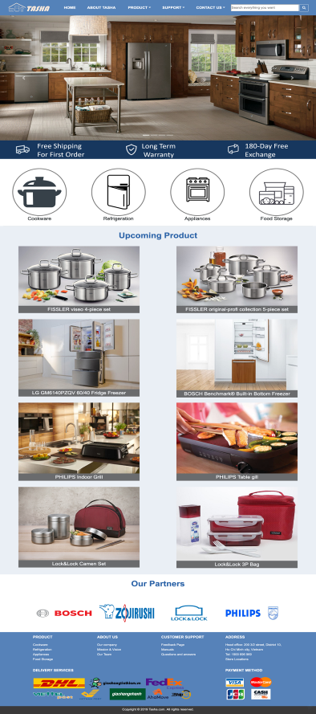

Home page shows Logo of Tasha company, navigation , slideshow of some special products, information about shipping/warranty promotion, some upcoming products and our brands

To be more, Footer also shows shortcut to other sites, shipping and payment method for customer.

Logo of Tasha company includes symbol of kitchen appliances under one roof and company name. It means where there’s Tasha’s products, there’s home.



Navigation bar includes links to **Homepage**, **about company**, **products** (which is divided by brands and by categories), **support** (link to feedback page, manuals, Q&As), **contact** ( head office and store locations) and searchbar



After that, the main impression of the page is the slideshow of some special products, additionally under slideshow is some highlighs about company policies on shipping, warranty and exchange. Under, there are logos of four product categories

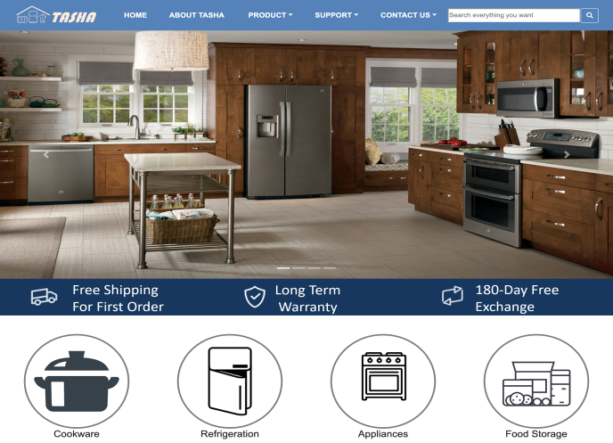

Then we show upcoming products and our partner brands

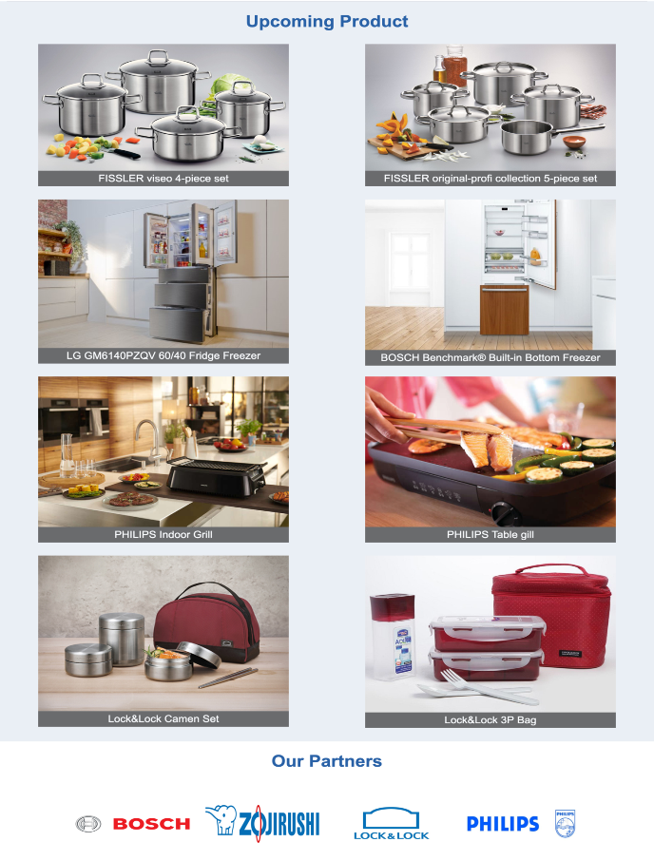

The footer is an important part,

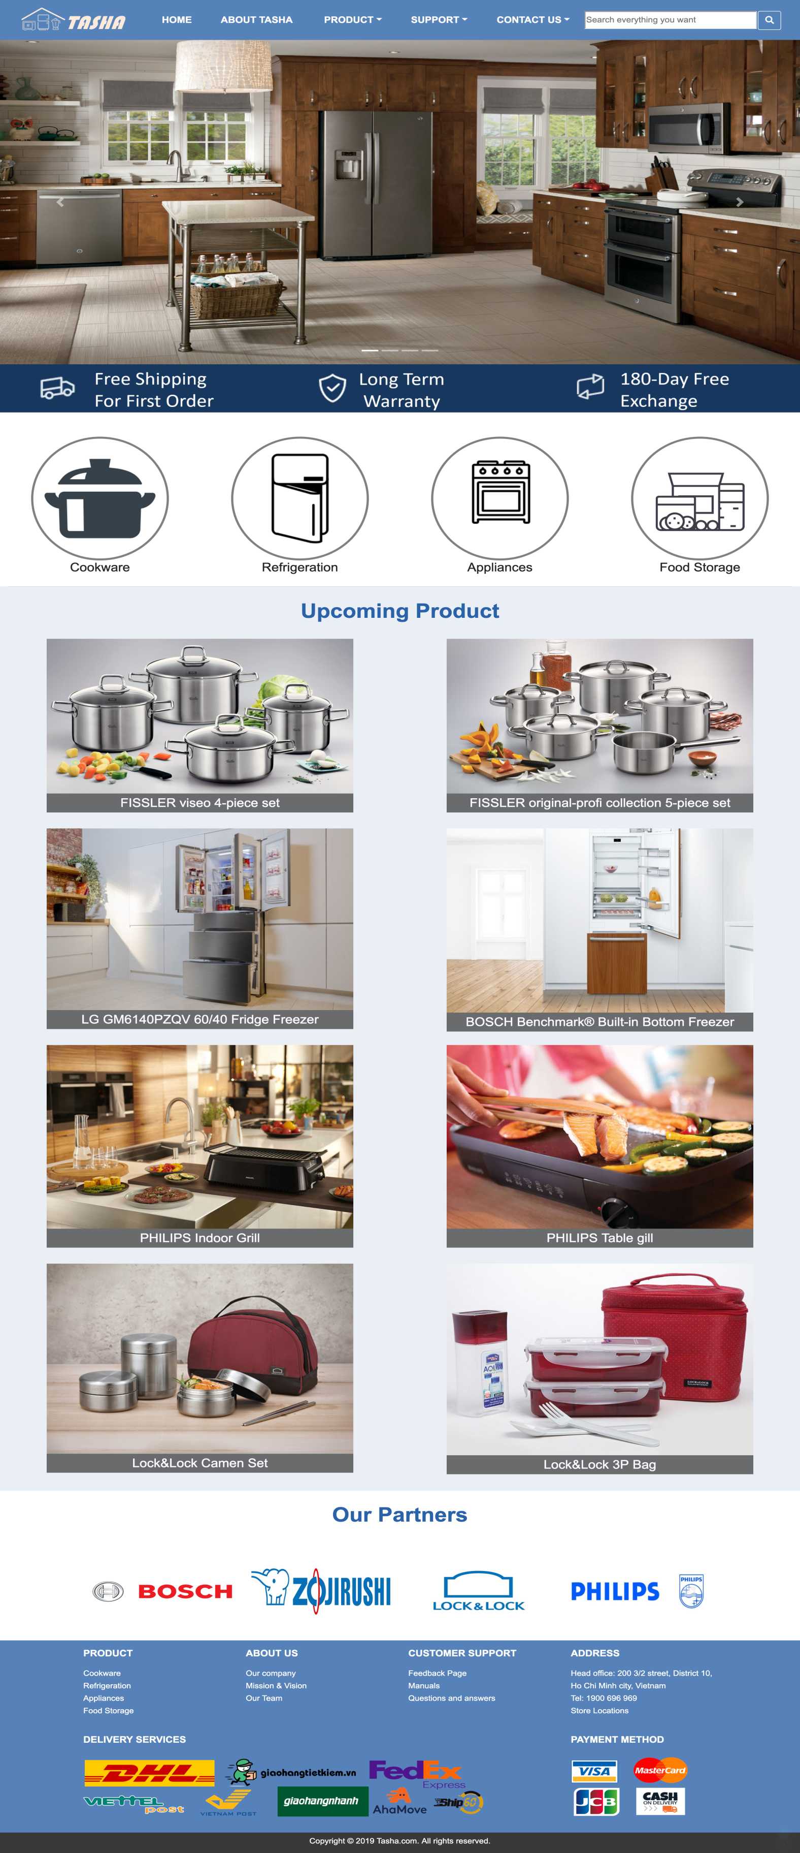

**II/ Cookware, Refrigeration, Apliances, Food Storage pages:**

Includes introduction and product collection

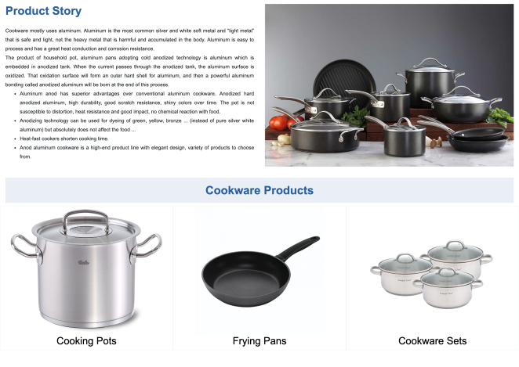

**III/ Categories product**

Picture categories product and high light of product in company

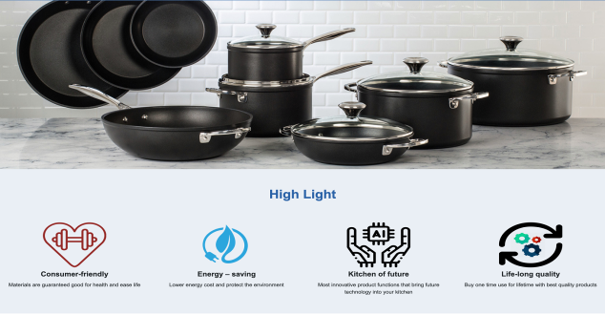

Each image get directive link to the detail page of that product if user want to see more infor about it.

List menu can support user find product of brand or all categories product easy

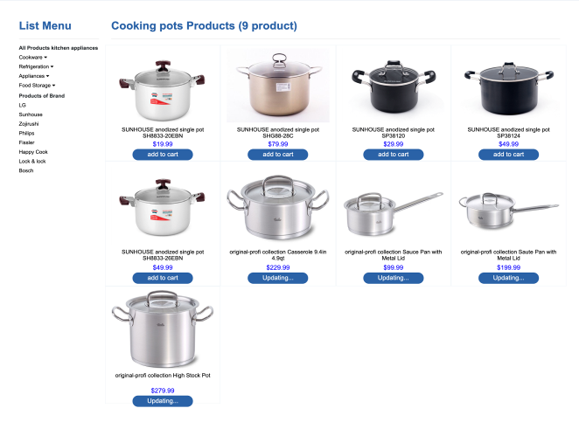

**IV/ Product of brand:**

Information introduction of brand

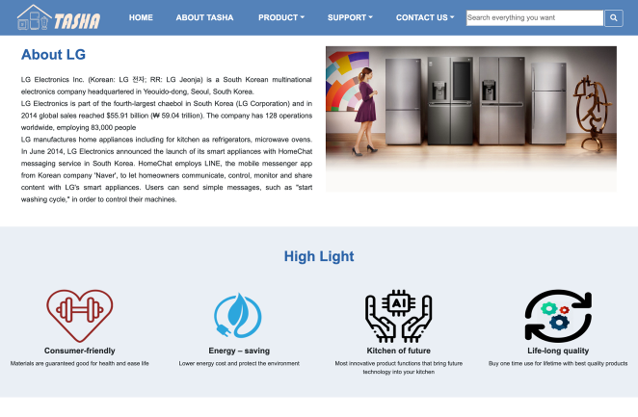

All products of one brand

Each image get directive link to the detail page of that product if user want to see more infor about it.

List menu can support user find product of brand or all categories product easy

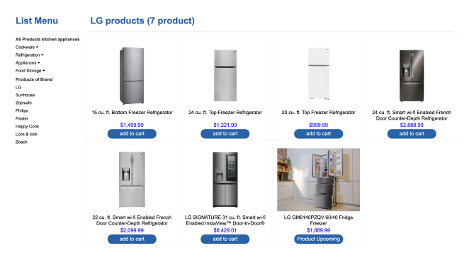

**V/ Detail pages:**

Detail page shows full information about product users are interested in.

Slideshow pictures of product and users can hover the image to see clearly the product.

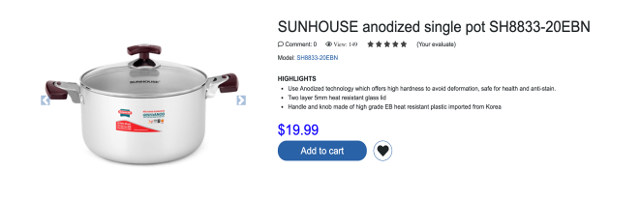

Product detail and specification of product.

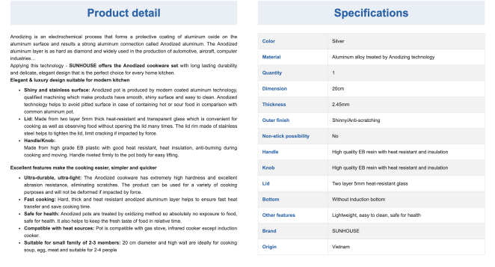

Slideshow products same category.

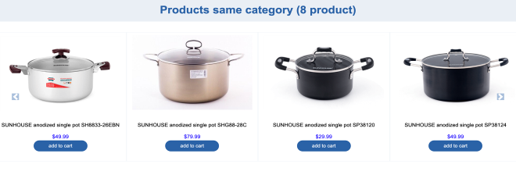

**VI/ Head office page:**

Showing the Address of Tasha company’s Headquarters, representing by google map

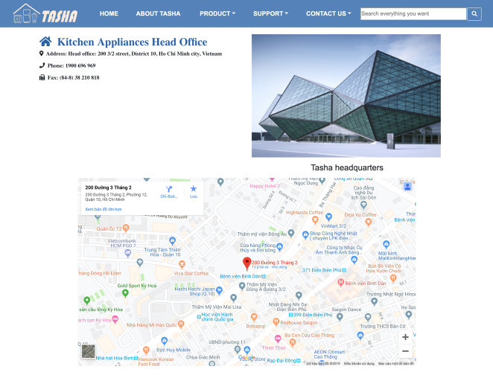

**VII/ Sale Locations page:**

List of Branches of Tasha, users can click on the list to find the office nearest to them:

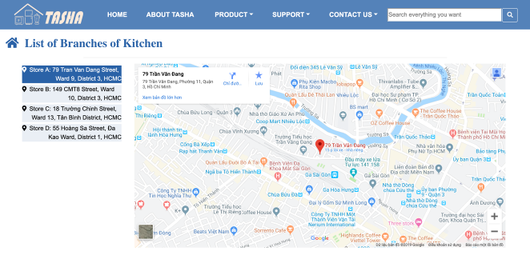

**VIII/ Feedback page**

Drawing a form where users could leave their feedback or questions about Tasha products

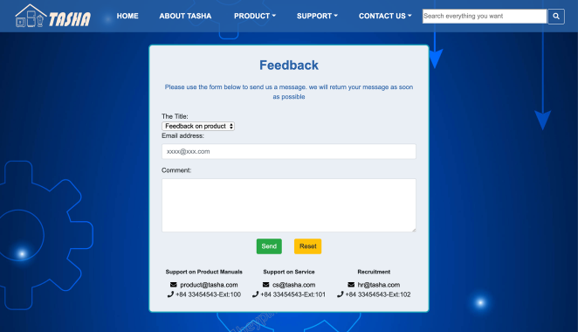

**IX/ Question and Answers**

Users can see some common questions and answers, giving questions to the company

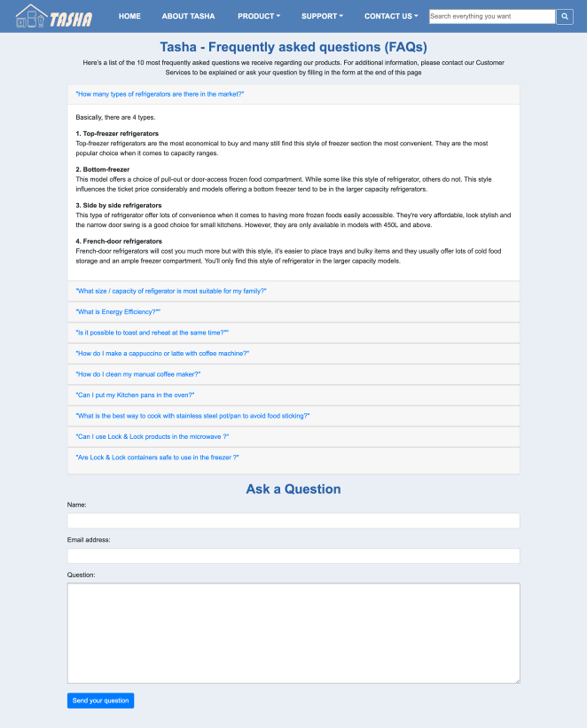

**X/ Manuals**

Users can download word filds to view the product's user guide

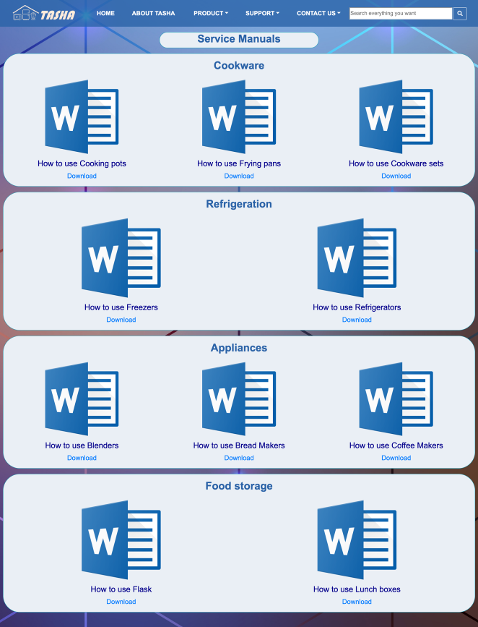

**XI/ About Tasha page:**

About Tasha company, mission and vision of Tasha.

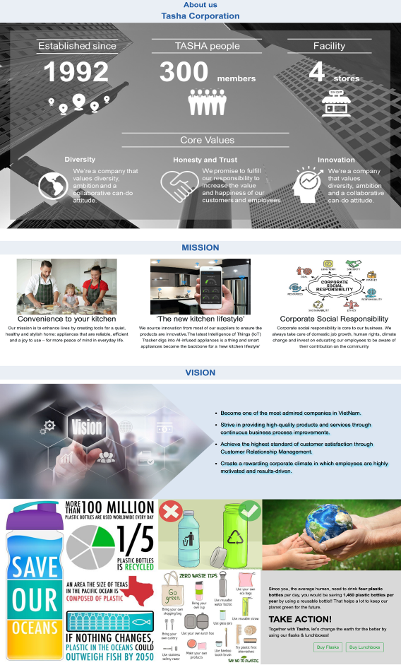

About our team



**Tasksheet review 3**

|  |  |  |  |  |  |  |  |
| --- | --- | --- | --- | --- | --- | --- | --- |
| ***Project Ref. No:***  ***eP/FANoFAN company website/01*** | | **Project Title:** | **Activity plan prepare by:** | **Date of preparation of activity plan:** | | | |
| **Sr.no.** | **Task** | **Actual start date:** | **Actual days** | **Team mate name** | **status** |
| 1 | Homepage | *Tasha company website* | Tâm | 13/7/2019 | 23 | Tâm | completed |
| 2 | Cookware, Refrigeration, Apliances, Food Storage pages | Tuẩn | completed |
| 3 | Categories product | Tâm | completed |
| 4 | Product of brand | Tâm | completed |
| 5 | Detail pages | Tâm | completed |
| 6 | About Tasha | Nhi | completed |
| 7 | Head office |  |  |  |  | Hoài | completed |
| 8 | Sale Location | Hoài | completed |
| 9 | Manuals | Tâm | completed |
| 10 | Q&A | Nhi | completed |
| 11 | Feedback page | Tuẩn | completed |

|  |  |
| --- | --- |
| **Date:** | |
| Signature of Instructor:  **Dao Ngoc Anh** | Signature of Team Leader:  **Nguyen Ngoc Anh Tam** |